Title (Times New Roman, 14 B) maximum 15 words

Full Name ¹, Full Name ^{2,*}, … (Times New Roman 12 B)

¹ affiliation (Times new Roman 12)
² affiliation (merge same addresses)

* Corresponding author: name@name.com ((Times new Roman 10)

Abstract
Maximum 250 words. Times new Roman 12. no enter, formula, reference. Justify. A manuscript must be submitted in a single file containing title, main text, figures, tables and graphs) in maximum 12 pages. Manuscripts should be submitted in Word based on this format. Paper A4 and 2.5 cm Margins.

Keywords: maximum 6 words. Times New Roman 12. Separate with ,

1. Introduction (main titles Times New Roman 12 B)
Main text with Times New Roman 12. In whole text, line spacing is 1 and spacing in before and after of paragraphs is 0. From second paragraphs, Indentation is 0.5 cm.
Articles should not exceed 12 pages, including all illustrations and references.
Use the automatic page numbering function to number the pages. Abbreviations should be numbered at first mention and used consistently thereafter. The full words of footnotes and abbreviations should be appeared at the end of the paper before references.
Appendices should be placed at the end of the manuscript, after the reference list. Acknowledgments of people, grants, funds, etc. should be placed in a separate section before the reference list. The names of funding organizations should be written in full.
Save your file in docx format (Word 2013 or higher) or doc format (older Word versions) no more than 5 MB.

2. Maximum pages
Maximum number of article pages is 12, which includes the text and all its components such as figures and tables, and for practical experience is between 5 to 15 pages.

3. Units
The SI standard unit system is the only acceptable problem-solving system. In special cases that requires to state the problem in other system, it is necessary to mention their SI standard equivalents. Note that the units are not forgotten for the values mentioned in the tables or the titles of the axes in the figures.

4. Tables and figures
Sub titles (Times New Roman 12 Italic)
All tables (i.e., data displayed in rows and columns) must be drawn as MS Word tables and embedded in the manuscript near the first reference to the corresponding table. All tables are to be numbered using Arabic numerals (Table1, Table 2, etc.) at the top of the table. Tables should always be cited in text in consecutive numerical order. For each table, please supply a table caption (title) explaining the components of the table.
Figure graphics (e.g., charts, graphs, photographs, and drawings) must be embedded in main file in appropriate resolution and black and white. Figures must be clearly labeled as Figure 1, Figure 2, etc., at the bottom of the figure, center justified, numbered in sequence, and must be referenced within the text of the article.
Formula in left and number in right. Hint: use hidden table for better alignment

$$A=πr^{2}$$ | (1)

Line spacing should be considered base on this guide. Figure and table title are like samples. Hint: use table for figure alignment and an addition row for table title

Table 1. Font of title and table: Times New Roman 10. Miss vertical lines. Left alignment
Title | Title (unit) | Title (unit)
a | 1 | 5
b | 2 | 6
c | 3 | 7
d | 4 | 8

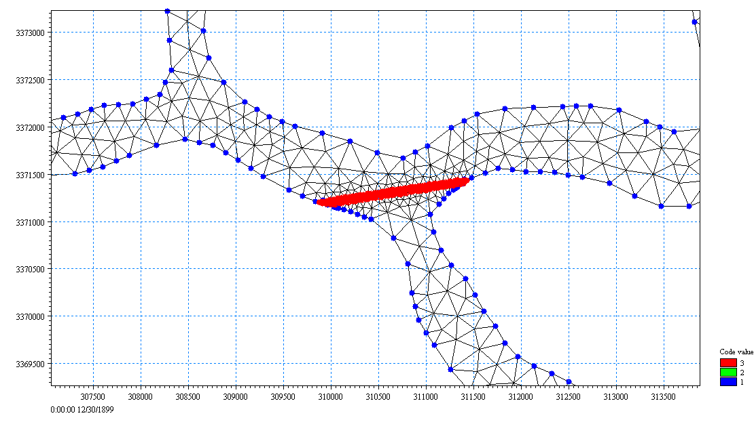
Figure 1. Font of title and table: Times New Roman 10, left alignment. Do not forget the title and unit for each axis.

References and cited in text should be checked carefully. For example: Ardestani (2012) or Ardestani and Padash (2011) and Ardestani et al. (2002). For references in parenthesis: (Ardestani, 2012; Ardestani and Padash, 2011; Ardestani et al., 2002).

5. Conclusions
Each article should provide specific explanations to summarize the research results presented in the conclusion section.

6. Acknowledgments
If necessary, Times New Roman 12. This study was supported by the Fundamental Research Funds for the …

7. Reference

Tabesh, M., Roozbahani, A., Roghani, B., Rasi Faghihi, N., and Heydarzadeh, R., (2018), “Risk assessment of factors influencing Non-Revenue Water using Bayesian Networks and Fuzzy Logic”, Water Resources Management, 31(9), 2561-2578.
In press papers:
Foladori, P., Tamburini, S. and Bruni, L. (2017), "Bacteria permeabilisation and disruption caused by sludge reduction technologies evaluated by flow cytometry", Journal of Water Research, in press.
Books:
Briere, F.G. (2014), Drinking-water distribution, sewage, and rainfall collection, Presses Internationals Polytechnique, Paris, France.
Part of a book:
Meltzer, P.S., Kallioniemi, A. and Trent, J.M., (2002), "Chromosome alterations in human solid tumors", in: B.Vogelstein & K.W. Kinzler (eds.), The genetic basis of human cancer, pp. 93-113, McGraw-Hill, New York, USA.
Institute instead of the writer:
WHO, (2011), Nitrate and nitrite in drinking-water-background document for development of WHO guidelines for drinking-water quality, World Health Organ, Geneva.
Conference papers:
Murphy, L.J., Dandy, G.C. and Simpson, A.R., (1994), "Optimum design and operation of pumped water distribution systems", Proceeding Conference on Hydraulics in Civil Engineering, Institution of Engineers, Brisbane, Australia, pp. 149-155.
Thesis and dissertations:
de Schaetzen, W., (2000), “Optimal calibration and sampling design for hydraulic network models”, Doctoral Dissertation, University of Exeter, Exeter, UK.
Internet websites:
Burka, L.P., (2003), "A hypertext history of multi-user dimensions", Viewed 5 July 2019, http://www.ccs.neu.edu./

